**User Account Control Setting**

**Version 1.0**

**Version History**

|  |  |  |  |
| --- | --- | --- | --- |
| **Version** | **Date** | **Handled by** | **Comments** |
| V1.0 | 03-June-2019 | ZL Chen | First version release. |
|  |  |  |  |

Precondition Setting:

N/A

Please follow the installation steps as below:

Step 1:

Please find the “User Account Control Setting” in windows, and click the “Change User Account Control settings” button.

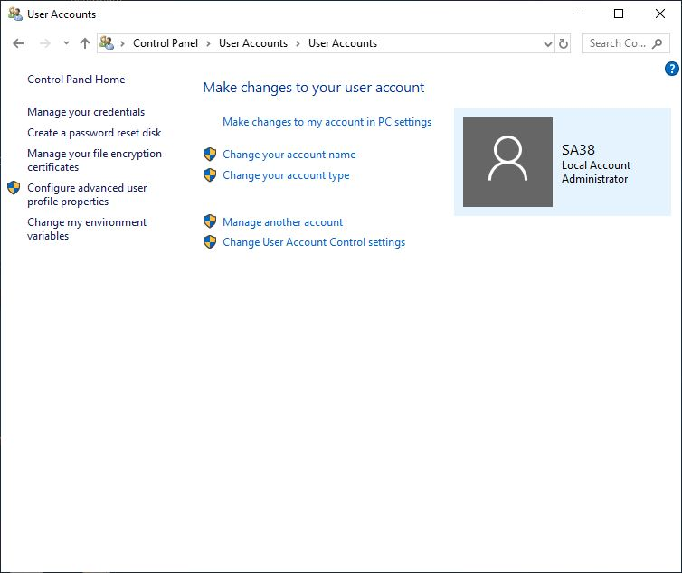

Step 2:

Change the setting to “Never notify me when”, then click the “OK” button.

